**Finding out the users role:**

The users role is buried in the payload of the token.

So, in the auth.service.ts file create the getRole() method

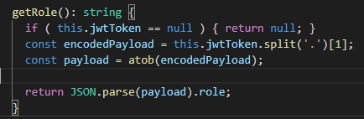

Go to the rooms.component.ts file:

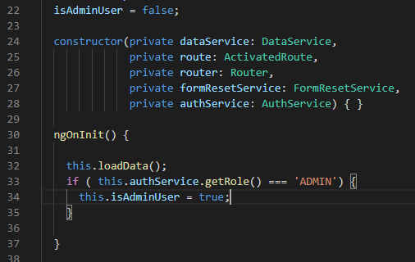

Now, the isAdmin can be used to hide/show the buttons:

Hide the Add button:



Hide the Edit and Delete buttons in the rooms-details.component.ts file:

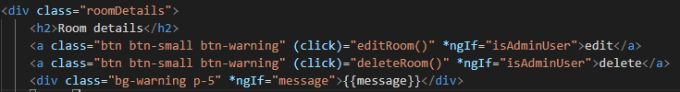

Now we can test these buttons by using jane(User) and matt(Admin):

First as jane:

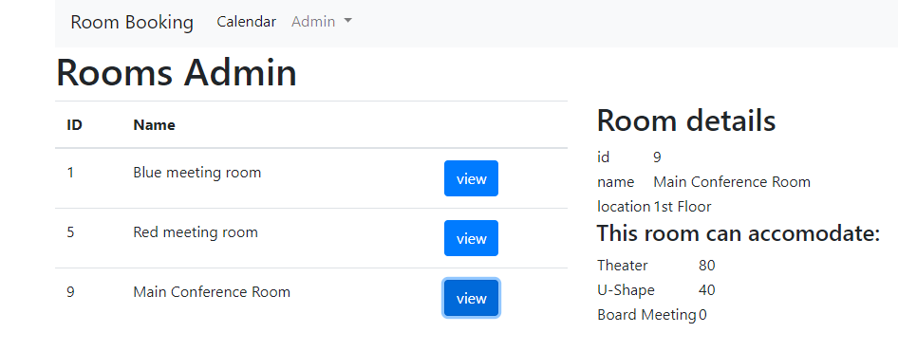

Second as matt:

